**Created by:**

Anh Tu NGUYEN G2 [*tunguyen.hust@gmail.com*](mailto:tunguyen.hust@gmail.com)

Thanh Tung TRINH G1 [*tungtrinhthanh@hotmail.com*](mailto:tungtrinhthanh@hotmail.com)



**UML OOP JAVA  
FINAL PROJECT REPORT  
“Epitrello”**

**Background of the project**

Project Management is always complicated and full of challenges. Hence, knowing the project going-on and tracking project status are the key elements of the successful project. In order to do that, we need efficient tools to hand on with the person in charge of project management. This is the key motivation for creating project “Epitrello”.

With “Epitrello”, users or project manager can easily distribute the task to all project team members and tracking all the jobs-to-be-done status at any time needed. “Epitrello” allows to create news users with task and relevant information about the task. Then it will give users the tracking function with timeline tracking in order to know the status as finished/ unfinished, as such users can have proper re-action on the tasks: assign, edit, move task. And finally, users can also see the performance of the project/task in order to have lesson and learning for upcoming projects.

**System Specifications**

* Java Open JDK8U
* Eclipse
* Operating System: Microsoft Windows 10
* Astah UML
* Team-work platform: SourceTree and GitHub

**Data Structure**

This project applied the Data Structure which used:

* ArrayList: We are storing tasks in User and TaskList as an ArrayList because the size of the ArrayList does not need to be initialized, therefore, elements can be added and removed from an ArrayList as many as necessary.
* Map: Because the program use username as a unique field to define user, so we use Map to store a map of users, with username as key and user as value. This helps us easier to find user.
* LinkedHashMap: Because HashMap cannot guarantee the order of each entry, so we use LinkedHashMap to remain the insertion order. This helps us to remain the order of list and task by creation order.

**UML Class Diagram**

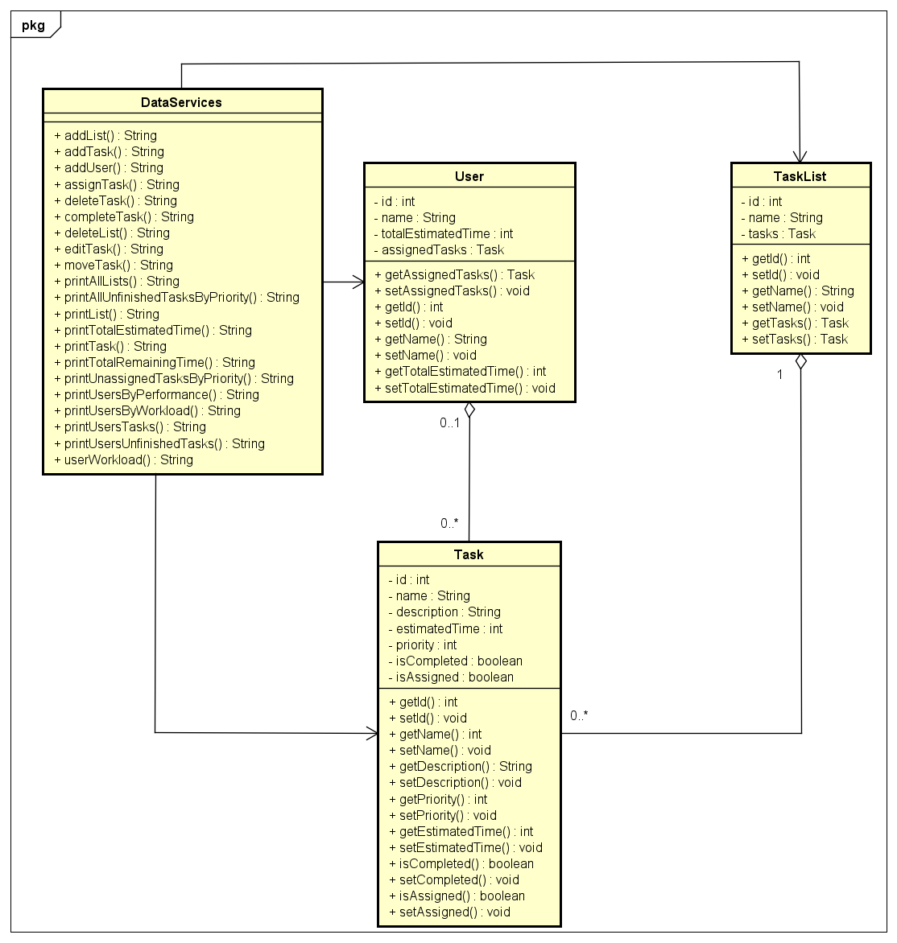

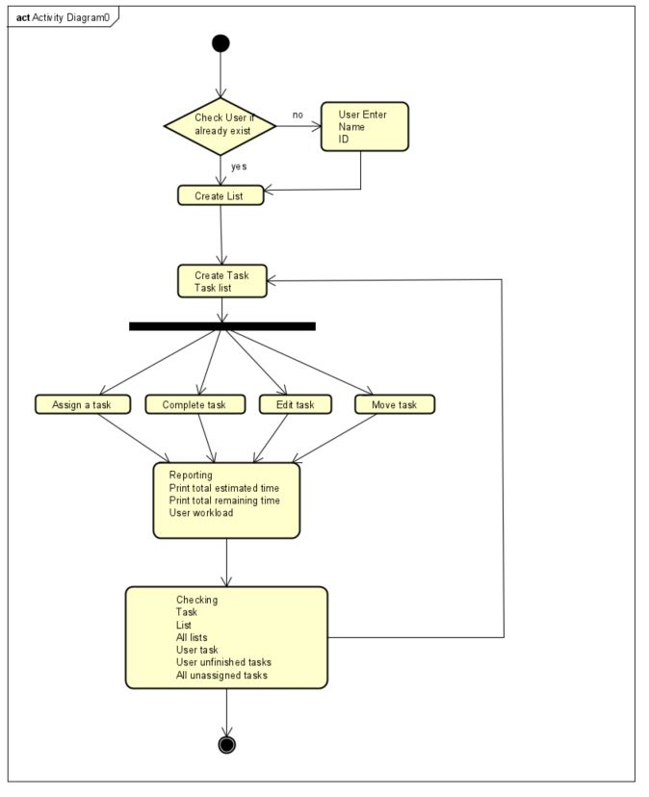**Activities Diagram**

**Software Architecture Diagram**

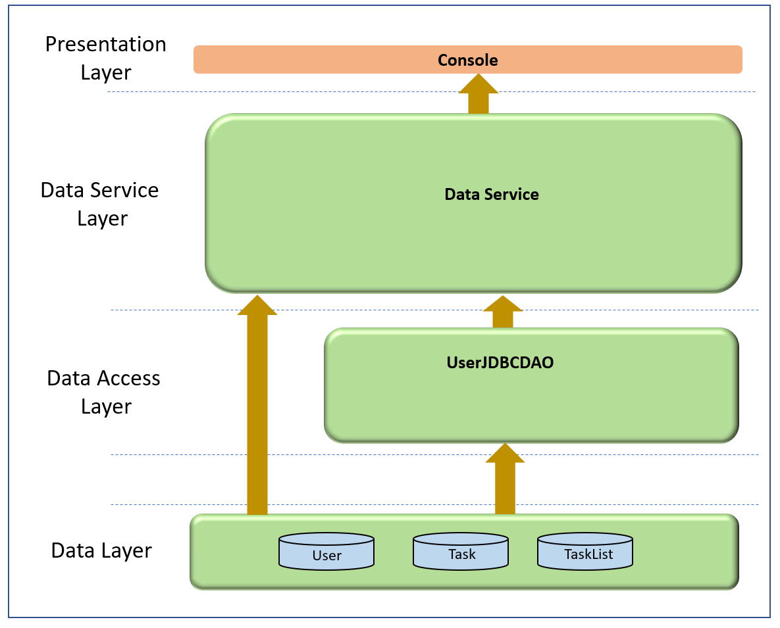

**Code Quality Report**

* **SonarLint Report**
* A picture containing electronics

  Description automatically generated
* **Javadoc**
* 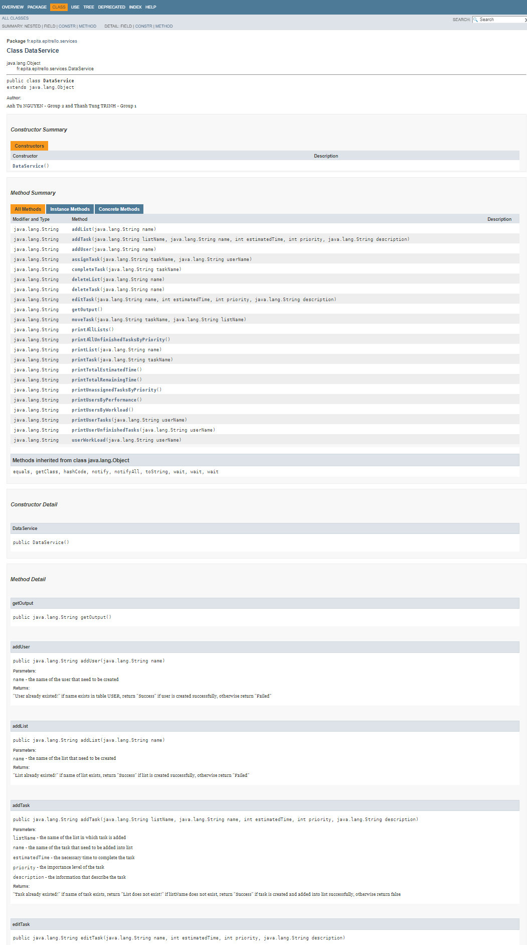

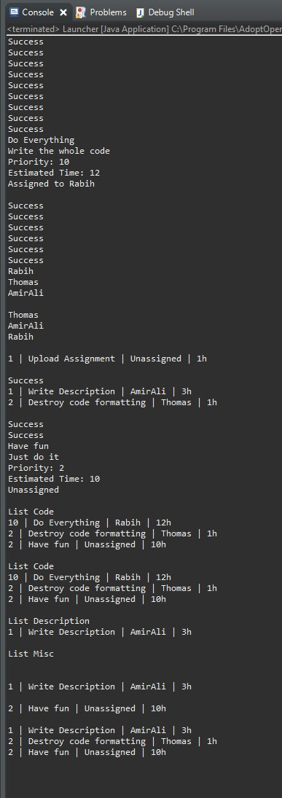**Screen Shot – Commented**